Adult Walk-In Clinic -Holiday Closures and Hours
Organization | Holiday hours | Location and contact
 | Closed December 25th and January 1st.  Regular hours will resume January 8th. Intake begins at 2:30pm | 355 Church street  Tel: 416-595-9230 ext. 0  Intake begins at 3:00pm and ends at 6:15pm
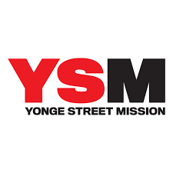 | Closed December 26th and January 2nd.  Regular hours will resume January 9th. | 270 Gerrard St Eat  Tel: 416 929-9614
 | Open December 17th, 24th, and 31st.  Intake from 12:00pm  Closed December 25th and January 1st. | 333 Sherbourne St.  Tel: 416 324-4100
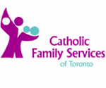 | Closed December 24th December 26th, December 31st and January 2nd  Regular hours will resume on the 7th at Yonge and the 9th at Fairview | 1155 Yonge Street Suite 200  Tel: 416 921- 1163  AND  245 Fairview Mall Drive Suite 201  Tel: 416 222-0048
 | Open December 23rd and December 30th 2019  Intake from 4:15pm-6:45pm  Closed December 25th, 26th, 31st and January 1st. Reg hours resume January 7th | 815 Danforth (Main Floor)  Tel: 416 645-6000

